*A*

*Project Report on*

*Submitted in the partial fulfilment of the requirement for the award of the degree of*

**IoT Based Smart Irrigation System**

**Bachelor of Technology**

*in*

**Electronics & Communication Engineering**

*Submitted by:*

**Dilip Kumar Singh**

**Harshit Shukla**

**Abhishek Ojha**

**Himanshu Pundir**

*Under the supervision of:*

***Dr. Pooja Lohia, Assistant Professor***

***Electronics & Communication Engineering***

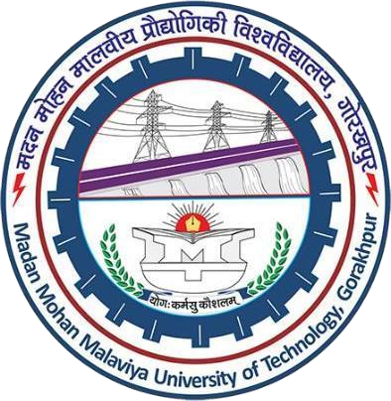

**Department of Electronics & Communication Engineering Madan Mohan Malaviya University of Technology,**

**Gorakhpur**

**(Session: 2023-24)**

**Abstract**

Agriculture is done in every country from ages. Agriculture is the science and art of cultivating plants. Agriculture was the key development in the rise of sedentary human civilization. Agriculture is done manually from ages. As the world is trending into new technologies and implementations it is a necessary goal to trend up with agriculture also. IOT plays a very important role in smart agriculture. IOT sensors are capable of providing information about agriculture fields. we have proposed an IOT and smart agriculture system using automation.

This IOT based Agriculture monitoring system makes use of wireless sensor networks that collects data from different sensors deployed at various nodes and sends it through the wireless protocol. This smart agriculture using IOT system is powered by Arduino, it consists of Temperature sensor, Moisture sensor, water level sensor, DC motor and GPRS module. When the IOT based agriculture monitoring system starts it checks the water level, humidity and moisture level. It sends SMS alert on the phone about the levels. Sensors sense the level of water if it goes down, it automatically starts the water pump. If the temperature goes above the level, fan starts. This all is displayed on the LCD display module.

It is also seen in IOT where it shows information of Humidity, Moisture and water level with date and time, based on per minute. Temperature can be set on a particular level. It is based on the type crops cultivated. If we want to close the water forcefully on IOT there is button given from where water pump can be forcefully stopped.

**Introduction**

An IoT-based smart cultivation project would involve the use of internet-connected devices and sensors to collect data on various aspects of crop growth and environmental factors, such as temperature, humidity, soil moisture, light, and nutrient levels. This data would be analyzed by software and used to optimize various aspects of crop cultivation, such as irrigation schedules, fertilization, and pest management.

The system could include sensors placed in the soil to measure moisture and nutrient levels, weather stations to measure temperature and humidity, and cameras or drones to monitor crop health. The data collected by these devices would be transmitted wirelessly to the cloud, where it would be analyzed by the software. The software could use machine learning algorithms to make predictions about crop growth, identify problems such as pests or disease, and make recommendations for corrective action.

The system could also include actuators such as irrigation systems or sprayers that can be controlled remotely via the software, allowing farmers to adjust irrigation schedules or apply pesticides as needed. The farmers can also access the system remotely via a web or mobile app, allowing them to monitor their fields and make adjustments as needed.

Additionally, the system could include a precision farming techniques, this is a method that uses technology such as GPS and sensors to collect data on weather, soil, and crop growth and then applies that data to make informed decisions about planting, fertilizing, harvesting, and other farming tasks.

IoT-based agriculture monitoring systems have several advantages over traditional farming methods. They can help farmers optimize irrigation schedules and reduce water usage, which can lead to cost savings and improved crop yields. The systems can also be used to detect pests and diseases early, which can help prevent crop loss. Additionally, farmers can access the system remotely via a web or mobile app, allowing them to monitor their fields from anywhere and make adjustments as needed.

**Motivation of Project**

There are several reasons why someone might be motivated to develop an IoT-based smart irrigation system project:

**1. Environmental concerns:** With climate change and water scarcity becoming increasingly pressing issues, many people are motivated to develop technologies that can help conserve water and reduce the environmental impact of agriculture.

**2. Increase crop yields:** By optimizing irrigation schedules and other farming practices, an IoT-based smart irrigation system has the potential to increase crop yields and improve food security.

**3. Cost savings:** By reducing water usage and improving crop yields, an IoT-based smart irrigation system can help farmers save money on water and fertilizer costs.

**4. Precision farming:** IoT-based systems use precision farming techniques, which allow farmers to make informed decisions about planting, fertilizing, harvesting and other farming tasks, resulting in more precise control over irrigation schedules and reducing water usage.

**5. Remote monitoring and control:** IoT-based systems can be accessed remotely via a web or mobile app, allowing farmers to monitor their fields from anywhere and make adjustments as needed, this makes it convenient for farmers to keep an eye on the irrigation schedule and make adjustments on the go.

**6. Predictive capabilities:** IoT-based systems use machine learning algorithms to make predictions about crop growth, identify problems such as pests or disease, and make recommendations for corrective action, which can help prevent crop loss.

**7. Advancement in technology:** The field of IoT is constantly evolving and developing new technology, creating opportunities for innovation and experimentation.

These are some of the reasons why someone might be motivated to develop an IoT-based smart irrigation system project, but the specific motivations will vary depending on the individual or organization involved.

**Circuit Digram**

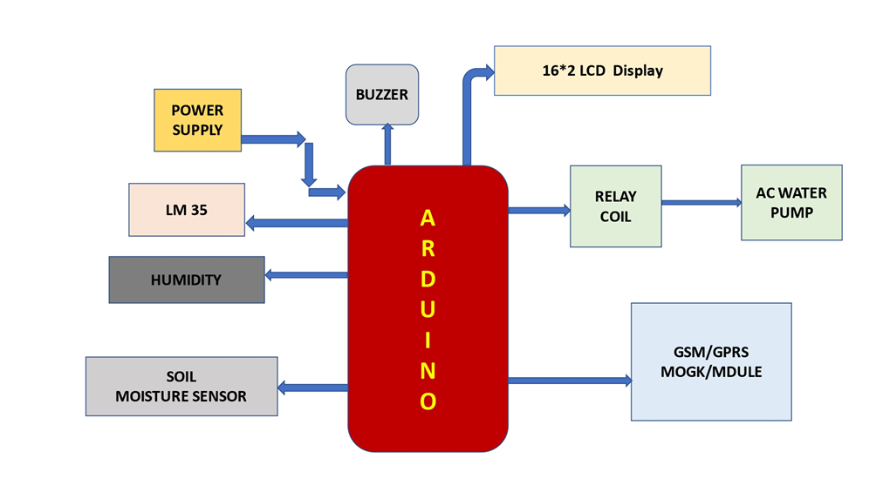

**Circuit Description**

**LM-35 Sensor :**

The LM35 is a precision integrated-circuit temperature sensor that can be used to measure temperature with an electrical output proportional to the temperature (in °C).

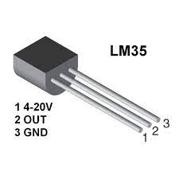

**Humidity Sensor:**

A humidity sensor is a device that measures the amount of moisture or water vapor present in the air. Humidity sensors are commonly used in various applications such as weather forecasting, industrial process control, HVAC systems, and medical equipment.

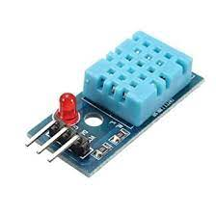

**Soil Sensor:**

A soil sensor is a device that measures various properties of soil, such as moisture content, pH, temperature, and electrical conductivity. There are several different types of soil sensors. Soil moisture sensors: These sensors measure the amount of water in the soil, typically by measuring the soil's electrical conductivity or dielectric constant.

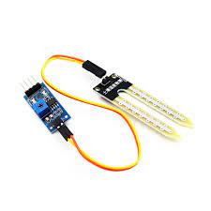

**LCD Display:**

A 16x2 LCD display is a type of liquid crystal display that can display 16 characters across two lines. It is commonly used in electronic devices such as computers, televisions, and mobile phones to display text and other information. The display is made up of a grid of pixels, each of which can be turned on or off to create the characters and images.

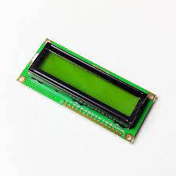

**GPRS Module:**

A GSM/GPRS module is a type of wireless module that allows devices to connect to a mobile network and access the internet. GSM (Global System for Mobile Communications) is a standard for mobile telephony systems, while GPRS (General Packet Radio Service) is a packet-based wireless communication service that enables data transfer through a mobile network. These modules typically include a built-in SIM card slot, which allows the device to connect to a specific mobile network operator. They also include a radio transceiver, which handles the communication between the device and the mobile network, and a microcontroller, which manages the module's functions. These modules can be integrated into devices such as embedded systems, IoT devices, and other electronic devices that require wireless connectivity.

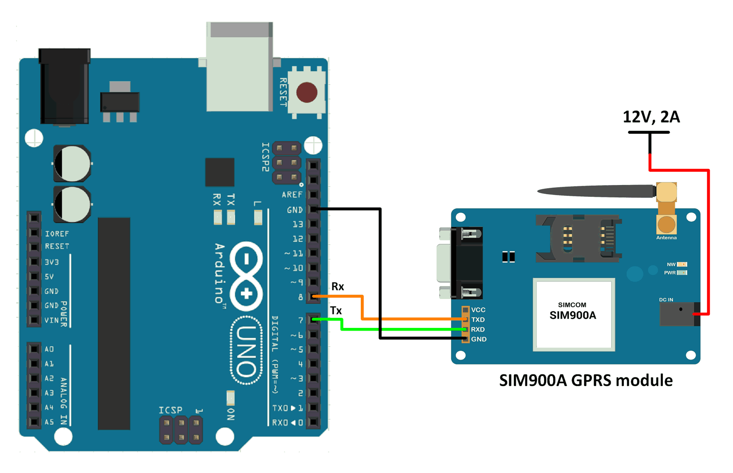

**Arduino UNO:**

The Arduino Uno is a microcontroller board based on the ATmega328P. It has 14 digital input/output pins, 6 analog inputs, a 16 MHz quartz crystal, a USB connection, a power jack, an ICSP header, and a reset button. It is programmed using the Arduino software (IDE), which is a simple programming language and a development environment that makes it easy to write, upload and run code on the board. The Arduino Uno can be used for a variety of projects, such as controlling lights and motors, reading sensors, and communicating with other devices using various communication protocols such as Bluetooth, WiFi, and Ethernet. It is a popular choice for beginners and hobbyists.

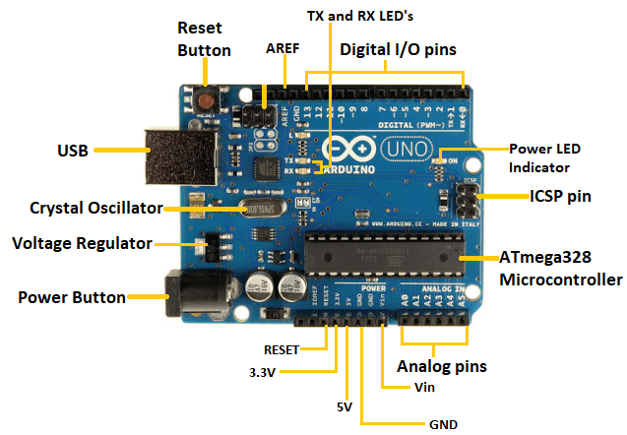

**Uniqueness of Project**

The uniqueness of an IoT-based smart irrigation system lies in its ability to collect real-time data on soil moisture, weather conditions, and other factors that affect crop growth, and use this data to optimize irrigation schedules and other farming practices. It also allows farmers to monitor their fields remotely and make adjustments as needed. Additionally, the following are some of the unique features of an IoT-based smart irrigation system:

**1. Precision farming:** IoT-based systems use precision farming techniques, which allow farmers to make informed decisions about planting, fertilizing, harvesting and other farming tasks, resulting in more precise control over irrigation schedules and reducing water usage.

**2. Predictive capabilities:** IoT-based systems use machine learning algorithms to make predictions about crop growth, identify problems such as pests or disease, and make recommendations for corrective action, which can help prevent crop loss.

**3. Remote monitoring and control:** IoT-based systems can be accessed remotely via a web or mobile app, allowing farmers to monitor their fields from anywhere and make adjustments as needed.

**4. Integration:** IoT-based systems can be integrated with other IoT devices, such as weather stations and drones, to provide a more comprehensive view of field conditions.

**5. Automation:** IoT-based systems can automate the irrigation schedules and other farming practices, reducing the need for manual labour and increasing efficiency.

**6. Real-time data:** IoT-based systems provide real-time data on soil moisture, weather conditions, and other factors that affect crop growth, allowing farmers to make more informed decisions.

**Impact of the Project**

IoT-based smart irrigation systems can have a significant impact on agriculture and the environment, some of the key impacts include:

**1. Increased crop yields:** By optimizing irrigation schedules and other farming practices, IoT-based smart irrigation systems have the potential to increase crop yields, which can help to improve food security.

**2. Water conservation:** By reducing water usage, IoT-based smart irrigation systems can help to conserve water, which is becoming increasingly important as water scarcity becomes a more pressing issue.

**3. Cost savings:** By reducing water usage and improving crop yields, IoT-based smart irrigation systems can help farmers save money on water and fertilizer costs.

**4. Precision farming:** IoT-based systems use precision farming techniques, which allow farmers to make informed decisions about planting, fertilizing, harvesting and other farming tasks, resulting in more precise control over irrigation schedules and reducing water usage.

**5. Remote monitoring and control:** IoT-based systems can be accessed remotely via a web or mobile app, allowing farmers to monitor their fields from anywhere and make adjustments as needed, this makes it convenient for farmers to keep an eye on the irrigation schedule and make adjustments on the go.

**6. Predictive capabilities:** IoT-based systems use machine learning algorithms to make predictions about crop growth, identify problems such as pests or disease, and make recommendations for corrective action, which can help prevent crop loss.

**7. Advancement in technology:** The field of IoT is constantly evolving and developing new technology, creating opportunities for innovation and experimentation.

Overall, IoT-based smart irrigation systems can have a significant impact on agriculture by increasing crop yields, conserving water, reducing costs, using precision farming techniques and remote monitoring and control, using predictive capabilities and advancing technology.

**Feasibility of the Project**

The feasibility of an IoT-based smart irrigation system project depends on various factors, such as:

**1. Technical feasibility:** IoT-based smart irrigation systems rely on a variety of technologies such as sensors, microcontrollers, actuators, communication modules, and cloud-based platforms. These technologies need to be compatible and reliable for the system to function properly.

**2. Economic feasibility:** The cost of the system, including the initial investment and ongoing maintenance costs, must be balanced against the potential cost savings and increased crop yields.

**3. Environmental feasibility:** The system must be designed in a way that minimizes the environmental impact, such as reducing water usage and preventing water pollution.

**4. Social feasibility:** The system must be designed to be user-friendly and easy to operate, and it must be acceptable to the farmers, communities, and other stakeholders.

**5. Legal feasibility:** The system must comply with all relevant laws and regulations related to agriculture, water use, and data privacy.

**6. Scalability:** The system should be scalable, so it can be expanded or modified as needed to accommodate future growth.

Overall, the feasibility of an IoT-based smart irrigation system project depends on a variety of factors, including technical feasibility, economic feasibility, environmental feasibility, social feasibility, legal feasibility and scalability. A thorough evaluation of these factors should be conducted before proceeding with the project.

**Conclusion**

An IoT-based smart irrigation and field monitoring system can provide numerous benefits for farmers and agricultural operations. By using sensors and connected devices to collect data on soil moisture levels, weather conditions, and crop growth, farmers can optimize their irrigation schedules and improve crop yields. Additionally, field monitoring can help detect and prevent potential issues such as pests and diseases. Implementing such a system can also lead to water conservation, as farmers can make more informed decisions about when and how much to water their crops. Overall, an IoT-based smart irrigation and field monitoring system can improve efficiency, increase crop yields, and reduce costs for farmers.

**Future Scope of Project**

The future scope of IoT-based smart irrigation projects is quite broad and has the potential to revolutionize the way we grow crops. Some potential future developments include:

**1. More advanced sensors:** As sensor technology advances, it will become possible to collect more accurate data on soil moisture, weather conditions, and other factors that affect crop growth. This will allow for even more precise control over irrigation schedules and farming practices.

**2. Increased automation:** IoT-based smart irrigation systems will be able to automate more and more farming tasks, reducing the need for manual labor and increasing efficiency.

**3. Predictive analytics:** IoT-based systems will use advanced machine learning algorithms to make more accurate predictions about crop growth and identify problems such as pests or diseases. This will allow farmers to take corrective action more quickly and prevent crop loss.

**4. Smart greenhouses:** IoT-based smart irrigation systems will be integrated with smart greenhouses to create a fully automated and controlled environment for crop growth.

**5. Remote monitoring:** IoT-based systems will allow farmers to monitor their fields remotely in real-time, using drones or other remote sensing technologies.

**6. Precision Agriculture:** IoT-based systems will integrate precision agriculture techniques to improve crop yields and reduce water usage, by applying the right amount of water and fertilizer at the right time.

**7. Interoperability:** The integration of IoT-based smart irrigation systems with other agriculture-related systems such as weather forecasting, crop modeling and market information systems will provide farmers with a more holistic view of their operations.

In summary, the future scope of IoT-based smart irrigation projects is wide and has the potential to revolutionize the way we grow crops by providing more precise control over irrigation schedules, increasing automation, using predictive analytics and remote monitoring, precision agriculture, and integrated smart greenhouse.

**References**

* *S. R. Prathibha; Anupama Hongal; M. P. Jyothi 2017 International Conference on Recent Advances in Electronics and Communication*
* *N. Ananthi; J. Divya; M. Divya; V. Janani 2017 IEEE Technological Innovations in ICT for Agriculture and Rural Development (TIAR)*
* *M Shanmugam Shoba; Sangeetha D; K L Suchala; R H Shravya; B S Soundhaaryha 2022 International Conference on Sustainable Computing and Data Communication Systems (ICSCDS)*
* *Fabrication of a multi-modal sensor with PH, EC and temperature sensing areas for agriculture application*
* *Masato Futagawa;Taichi Iwasaki;Hidekuni Takao;Makoto Ishida;Kazuaki Sawada;Hidekuni Takao;Makoto Ishida;Kazuaki Sawada*
* *SENSORS, 2009 IEEE*
* *https://circuitdigest.com/microcontroller-projects/iot-based-smart-agriculture-moniotring-system*
* *https://www.elprocus.com/smart-irrigation-system-using-iot/*
* *https://iotdesignpro.com/projects/smart-irrigation-system-using-iot*